Test Case: tc005_SPX_Dev5_Crear_Requisicion_Spot_Con_FAD_Tipo_Cobro_Project
Step 1 - Enter username and password and click to button Enter: Credentials Entered
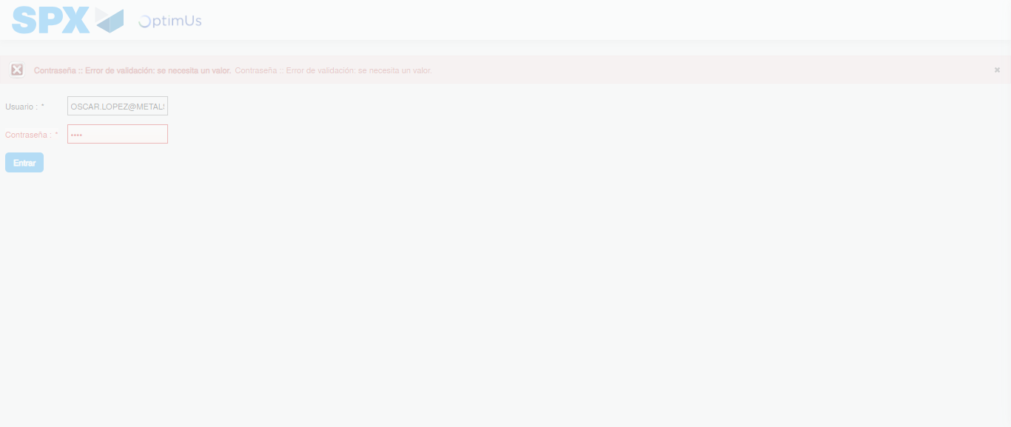Image file-name: QC_Testing-tc005_SPX_Dev5_Crear_Requisicion_Spot_Con_FAD_Tipo_Cobro_Project-1784653298217

Step 2 - Select to UEN and Access to Spot Buy Requisitions : UEN Correctly selected and Correct access
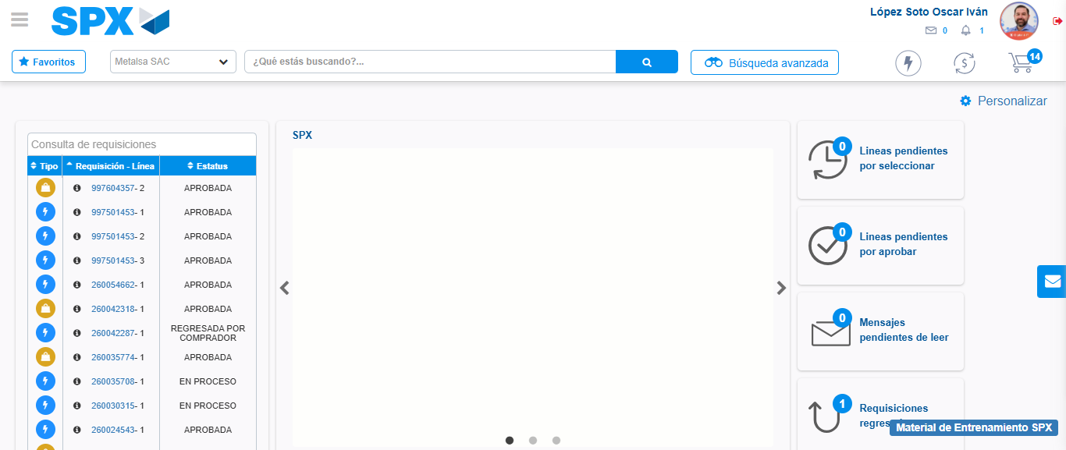Image file-name: QC_Testing-tc005_SPX_Dev5_Crear_Requisicion_Spot_Con_FAD_Tipo_Cobro_Project-1784653348229

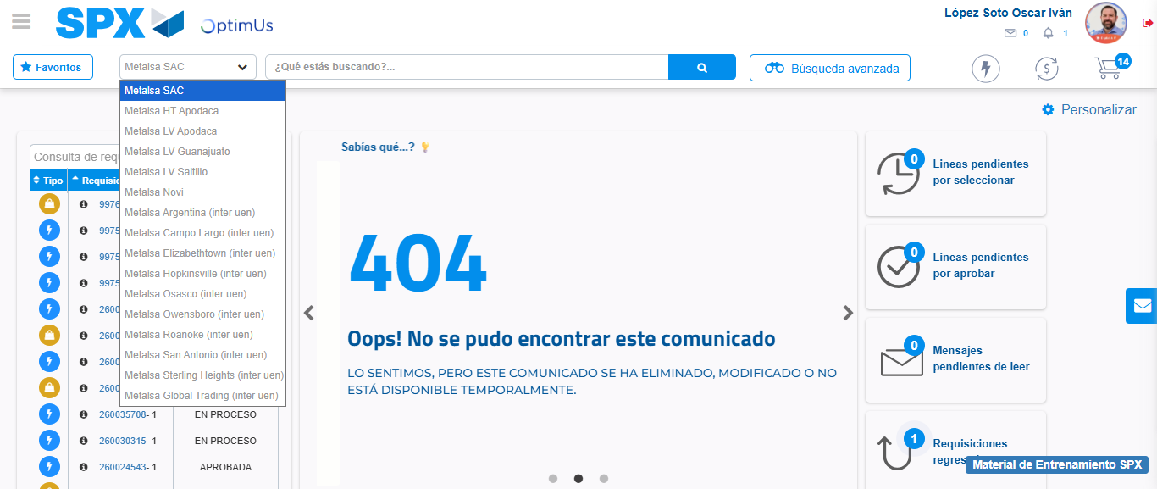Image file-name: QC_Testing-tc005_SPX_Dev5_Crear_Requisicion_Spot_Con_FAD_Tipo_Cobro_Project-1784653350989

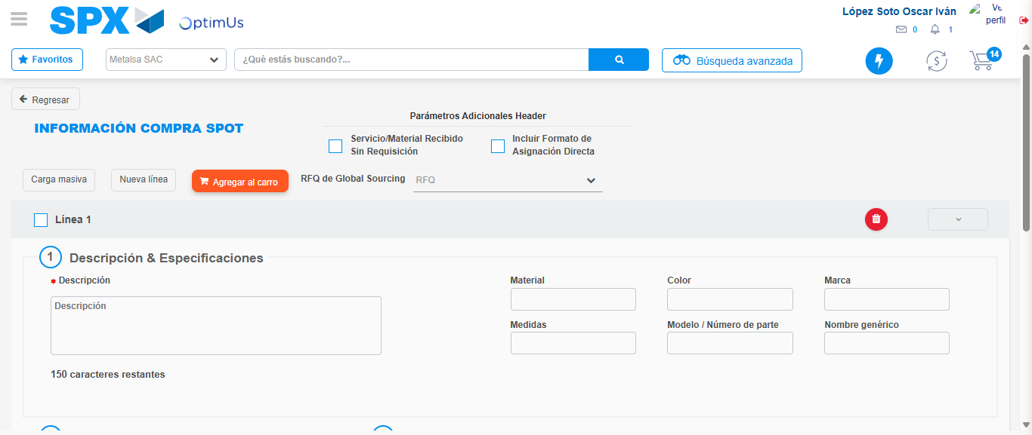Image file-name: QC_Testing-tc005_SPX_Dev5_Crear_Requisicion_Spot_Con_FAD_Tipo_Cobro_Project-1784653360333

Step 3 - Add FAD to Requisition: FAD Successfully Added
Image file-name: QC_Testing-tc005_SPX_Dev5_Crear_Requisicion_Spot_Con_FAD_Tipo_Cobro_Project-1784653360617

Image file-name: QC_Testing-tc005_SPX_Dev5_Crear_Requisicion_Spot_Con_FAD_Tipo_Cobro_Project-1784653360841

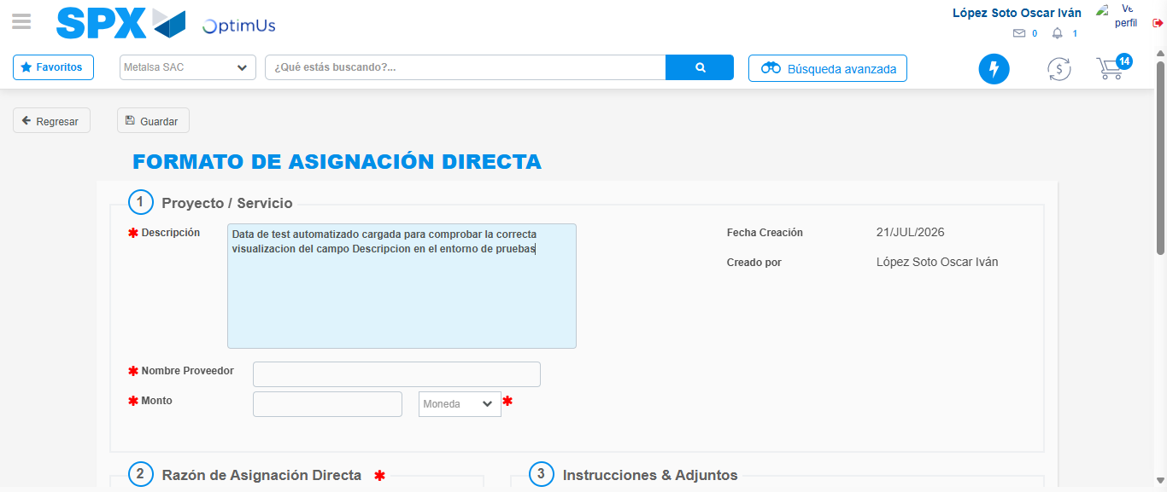Image file-name: QC_Testing-tc005_SPX_Dev5_Crear_Requisicion_Spot_Con_FAD_Tipo_Cobro_Project-1784653363902

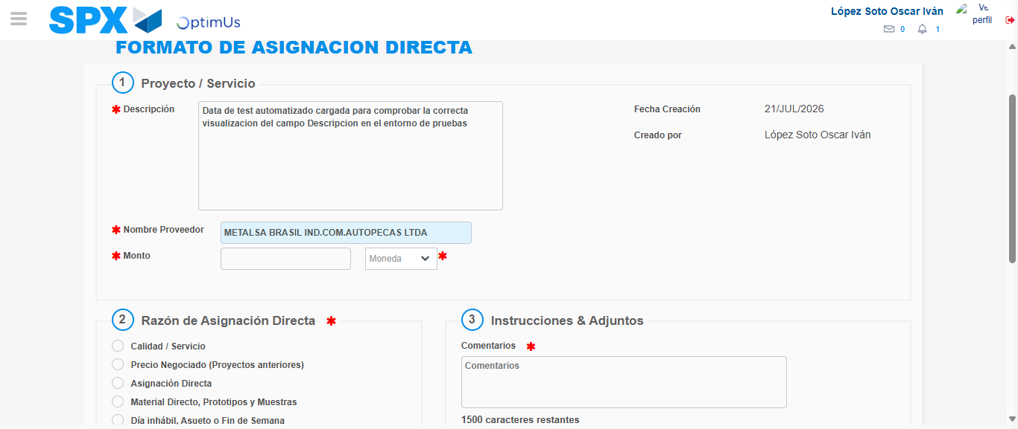Image file-name: QC_Testing-tc005_SPX_Dev5_Crear_Requisicion_Spot_Con_FAD_Tipo_Cobro_Project-1784653370778

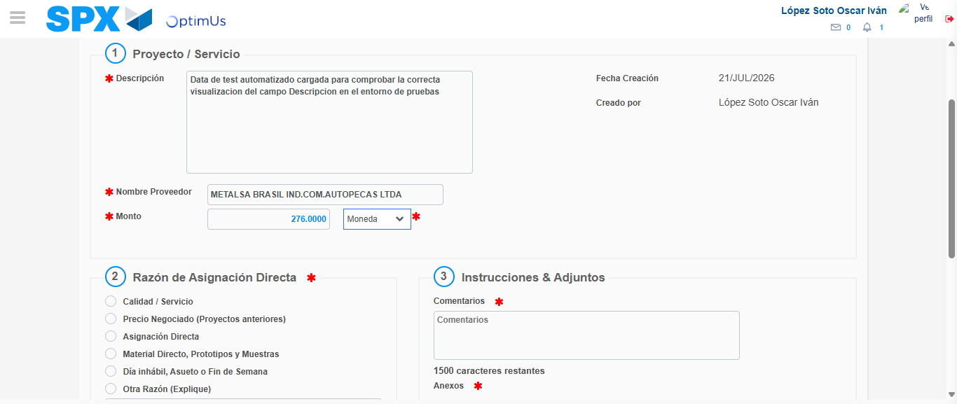Image file-name: QC_Testing-tc005_SPX_Dev5_Crear_Requisicion_Spot_Con_FAD_Tipo_Cobro_Project-1784653371331

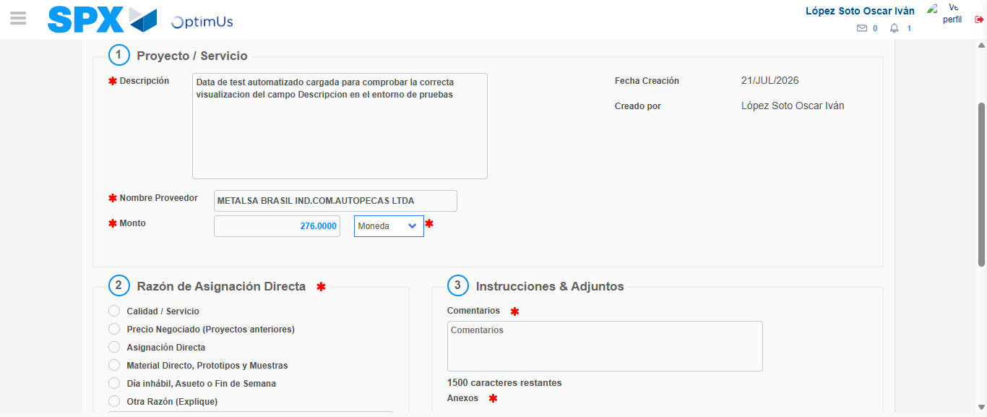Image file-name: QC_Testing-tc005_SPX_Dev5_Crear_Requisicion_Spot_Con_FAD_Tipo_Cobro_Project-1784653371579

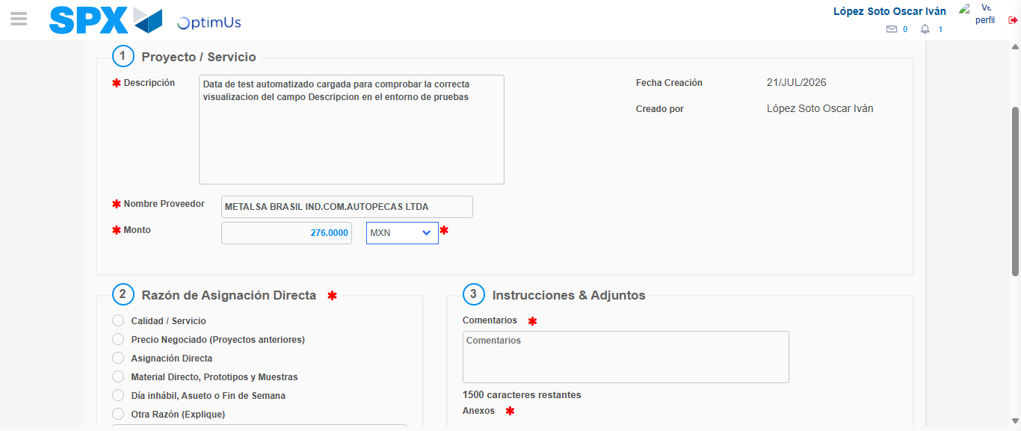Image file-name: QC_Testing-tc005_SPX_Dev5_Crear_Requisicion_Spot_Con_FAD_Tipo_Cobro_Project-1784653372028

Image file-name: QC_Testing-tc005_SPX_Dev5_Crear_Requisicion_Spot_Con_FAD_Tipo_Cobro_Project-1784653372224

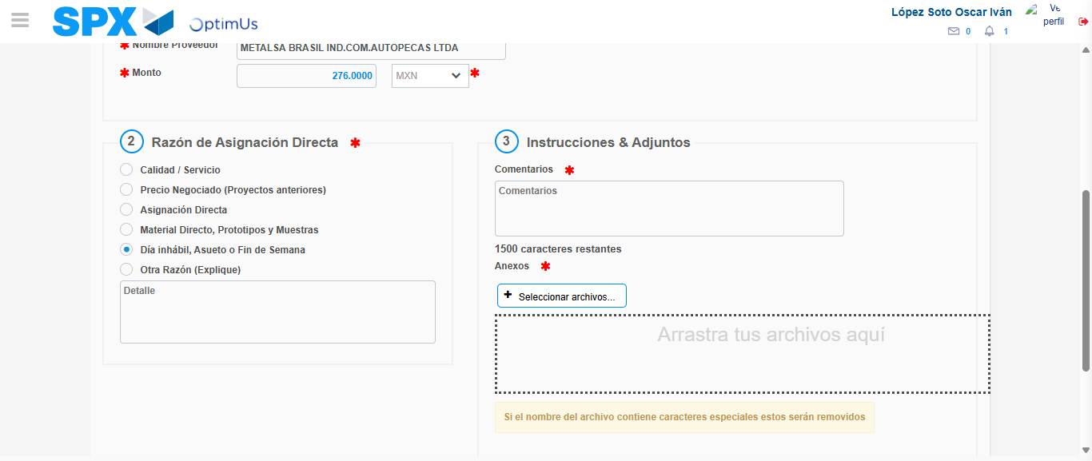Image file-name: QC_Testing-tc005_SPX_Dev5_Crear_Requisicion_Spot_Con_FAD_Tipo_Cobro_Project-1784653373204

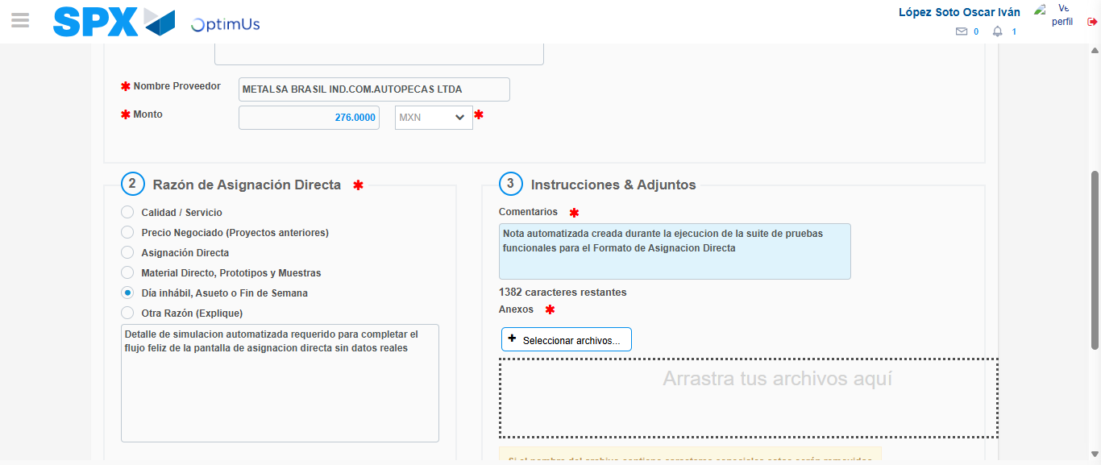Image file-name: QC_Testing-tc005_SPX_Dev5_Crear_Requisicion_Spot_Con_FAD_Tipo_Cobro_Project-1784653384506

Image file-name: QC_Testing-tc005_SPX_Dev5_Crear_Requisicion_Spot_Con_FAD_Tipo_Cobro_Project-1784653385311

Step 4 - Data Capture Spot Buy Requisition: Data captured correctly
Image file-name: QC_Testing-tc005_SPX_Dev5_Crear_Requisicion_Spot_Con_FAD_Tipo_Cobro_Project-1784653360617

Image file-name: QC_Testing-tc005_SPX_Dev5_Crear_Requisicion_Spot_Con_FAD_Tipo_Cobro_Project-1784653360841

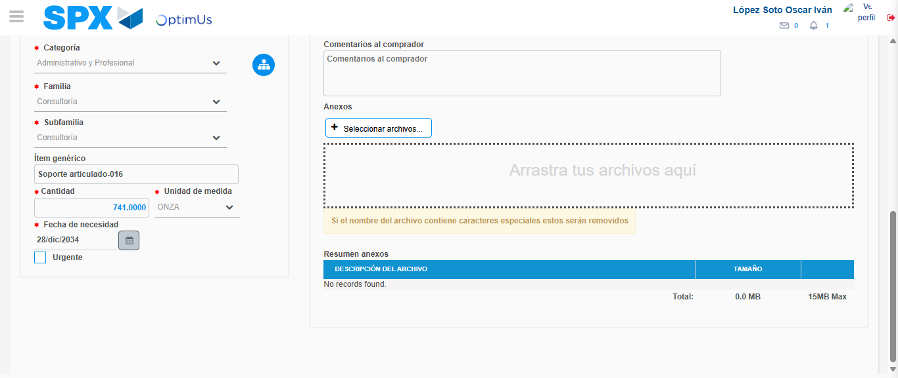Image file-name: QC_Testing-tc005_SPX_Dev5_Crear_Requisicion_Spot_Con_FAD_Tipo_Cobro_Project-1784653398754

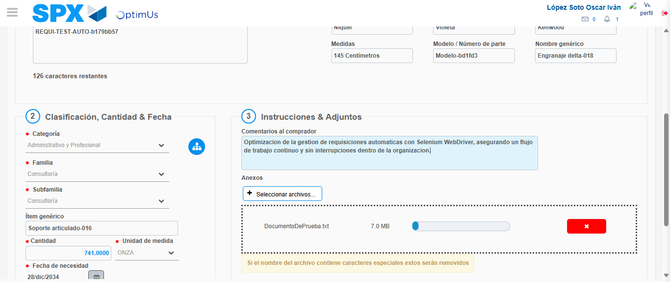Image file-name: QC_Testing-tc005_SPX_Dev5_Crear_Requisicion_Spot_Con_FAD_Tipo_Cobro_Project-1784653399715

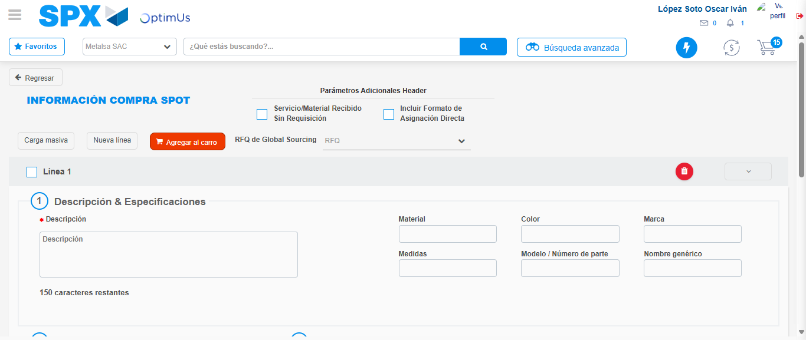Image file-name: QC_Testing-tc005_SPX_Dev5_Crear_Requisicion_Spot_Con_FAD_Tipo_Cobro_Project-1784653407158

Step 8 - Return to Main Page SPX : Return to Main Page SPX
Image file-name: QC_Testing-tc005_SPX_Dev5_Crear_Requisicion_Spot_Con_FAD_Tipo_Cobro_Project-1784653348229

Image file-name: QC_Testing-tc005_SPX_Dev5_Crear_Requisicion_Spot_Con_FAD_Tipo_Cobro_Project-1784653350989

Image file-name: QC_Testing-tc005_SPX_Dev5_Crear_Requisicion_Spot_Con_FAD_Tipo_Cobro_Project-1784653360333

Image file-name: QC_Testing-tc005_SPX_Dev5_Crear_Requisicion_Spot_Con_FAD_Tipo_Cobro_Project-1784653409464

Image file-name: QC_Testing-tc005_SPX_Dev5_Crear_Requisicion_Spot_Con_FAD_Tipo_Cobro_Project-1784653409657

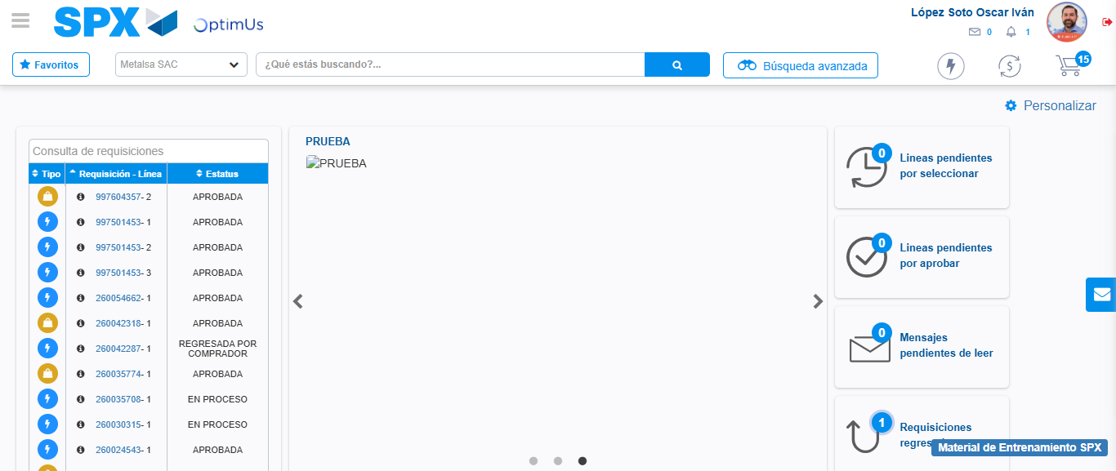Image file-name: QC_Testing-tc005_SPX_Dev5_Crear_Requisicion_Spot_Con_FAD_Tipo_Cobro_Project-1784653431049

Step 9 - Log Out : Log Out SPX
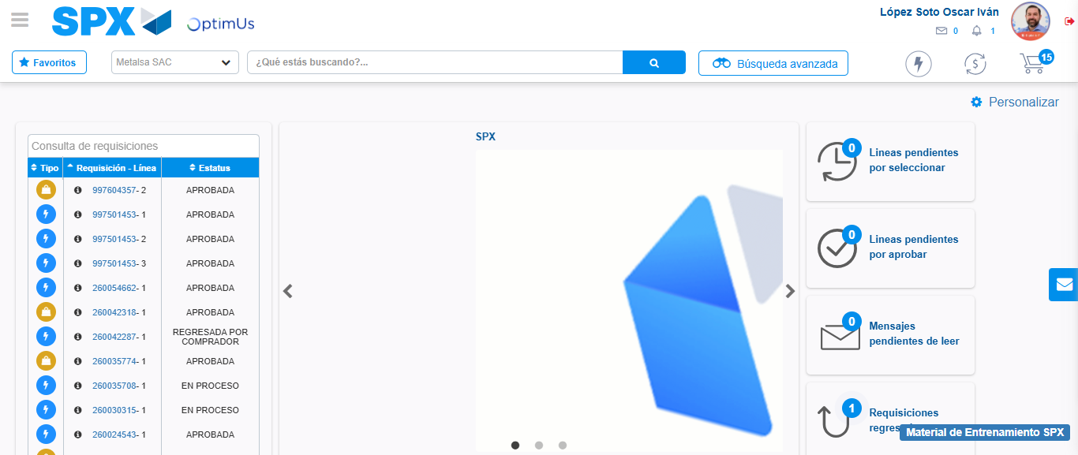Image file-name: QC_Testing-tc005_SPX_Dev5_Crear_Requisicion_Spot_Con_FAD_Tipo_Cobro_Project-1784653431459

